**Power outages increase cardiovascular and respiratory hospitalizations among US older adults**

**Heather McBrien1*, Daniel Mork2, Vivian Do1, Marianthi-Anna Kioumourtzoglou1, Joan A. Casey3,4**

**1 Columbia Mailman School of Public Health, Department of Environmental Health Sciences**

**2 Harvard T. H. Chan School of Public Health, Department of Biostatistics**

**3 University of Washington Department of Environmental and Occupational Health Sciences**

**4 University of Washington Department of Epidemiology**

**\* Corresponding author:** [**hm2913@cumc.columbia.edu**](mailto:hm2913@cumc.columbia.edu)

**Funding sources:**

**National Institute on Aging grant R01AG071024 (JAC)**

**National Institute of Environmental Health Sciences grant P30ES007033 (JAC)**

**National Institutes of Health R01ES034021 (DM)**

**National Institutes of Health R01AG066793 (DM)**

**National Institute on Aging P20 AG093975 (MAK)**

**National Institute of Environmental Health Sciences P30 ES009089 (MAK)**

**Canadian Institute for Health Research Doctoral Foreign Study Award (HM)**

**National Heart, Lung, and Blood Institute (NHLBI) F31 HL172608 (VD)**

**Abstract (max 250 words)**

**Background**: In the United States, already prevalent power outages are increasing in frequency and duration with climate change. Studies from New York State show that power outages may increase hospitalizations for cardiovascular (CVD) and respiratory disease in vulnerable populations such as older adults, but exposure data limitations have constrained nationwide studies of power outage and health.

**Question**: Are power outages associated with emergency CVD and respiratory disease-related hospitalizations among older adults in the United States?

**Methods**: We developed a national dataset of power outage exposure and identified county-days where ≥1% of customers were exposed to 8+ hour power outages in 2018. We leveraged data on 23 million Medicare Fee-For-Service beneficiaries aged 65+ to estimate daily county-level rates of emergency CVD- and respiratory-related hospitalizations. We applied a case-crossover design with a conditional Poisson model to estimate the lagged association (up to 1 week) between daily county-level power outage exposure and cause-specific hospitalization rates. Models controlled for daily temperature, precipitation, and wind speed.

**Results**: Power outages increased both emergency CVD and respiratory hospitalizations. Effects of outage on CVD hospitalizations were largest the day after power outage exposure (rate ratio [RR]=1.02, 95% CI: 1.01, 1.03. Effects of outage on respiratory hospitalizations were largest the day of outage exposure (RR=1.03, 95% CI: 1.01, 1.04).

**Conclusion**: Power outages may cause CVD and respiratory hospitalizations among US older adults. Improving electricity reliability could support community health and protect older adults from CVD and respiratory disease exacerbations.

**Significance Statement (max 120 words):** Power outage frequency is increasing with climate change. Outages serious risks to older adults’ health: heat and cold exposure and loss of power to medical and mobility devices following outages can cause hospitalization. To study the health impacts of outage, we developed a national dataset of power outage exposure. With additional claims data from 23 million Medicare Fee-For-Service beneficiaries age 65+, we conducted a case-crossover study of daily county-level power outage exposure and cardiovascular and respiratory hospitalization rates. We found that power outage exposure was associated with increased next-day hospitalizations for cardiovascular disease, and increased same-day hospitalizations for respiratory disease among older adults. Our results suggest that improving electricity reliability could protect older adults from outage-related cardiorespiratory hospitalizations.

**Introduction:**

As the climate warms, the incidence and duration of power outages across the US is increasing (1). US electrical customers experienced an average of 8 hours without power in 2020—the longest duration on record (2). Aging electrical grid components, already at risk of failure, were not built to withstand previously rare extreme weather events now common with climate change (3, 4). 40-60% of major outages are now caused by severe weather events (5). Additionally, extreme heat and cold events will continue to increase electricity use, outstripping supply and causing outages (6, 7).

Power outages threaten the health of vulnerable populations such as older adults (3, 8). Outages disable air conditioners and heaters and expose those affected to extreme temperatures (9). This heat and cold exposure may cause or exacerbate cardiovascular (CVD) and respiratory illness. Older adults are more likely to suffer health consequences from heat and cold exposure due to aging-related thermoregulation changes (10–12) and due to preexisting CVD or respiratory disease (13, 14). Greater than 70% of older adults live with CVD (15). Additionally, over 3% of older adults use electricity-dependent medical equipment such as ventilators and oxygen tanks at home to treat conditions like chronic obstructive pulmonary disease (3). For these individuals, loss of electricity can be directly life-threatening. Finally, prolonged loss of electricity to refrigerators, elevators, wheelchairs, and water disruptions can result in stress, isolation, dehydration, or injury. Older adults’ increased reliance on mobility devices, elevators, and increased social isolation (16–18) may reduce their opportunities to seek electricity, air conditioning, heat, or water to mitigate outage impacts, putting them at higher risk for outage-related cardiovascular and respiratory illness.

Prior epidemiologic studies in New York State found elevated cardiovascular and respiratory emergency department visits up to one week after power outage exposure for all adults, as well as increased cardiovascular and respiratory hospitalizations and mortality (19–22).Associations may be stronger among older adults and when outdoor temperatures are extreme (20). Population-level datasets of power outage exposure beyond New York State have only become available since 2020, limiting national-scale studies of power outage and health (3, 5, 23).

We previously assembled the first nationwide dataset of hourly county-level power outage exposure from 2018-2020 based on data from PowerOutage.us (5, 24). Here, we leveraged these data together with 2018 older adult Medicare Fee-For-Service hospitalization claims to estimate the relationship between daily county-level power outage exposure and cardiovascular and respiratory hospitalization rates in the United States in a case-crossover study. We evaluated the impacts of moderate and large-scale power outages, and conducted secondary analyses examining effect measure modification by age, sex, poverty, and electricity-dependent durable medical equipment (DME) use.

**Results**

Our analysis included 2,161 counties, covering 71.1% of 2018 older adult Medicare Fee-For-Service beneficiaries age 65+ (N = 23,622,770). These counties experienced an average of 7 (SD=28) 8+ hour power outages affecting ≥1% of customers in 2018. The number of beneficiaries per county ranged from 0 to 252,004. Outages affecting ≥1% of county customers affected on average ≥109 Medicare Fee-For-Service beneficiaries. Just over two percent of county-days were exposed to a power outage (n=15,990 county-days) (**Table 1**). On average, days with more precipitation had fewer outages, while colder days and windier days had more outages (**Supplemental Table 1)**.

On average there were 3.23 CVD hospitalizations per county-day, and 2.25 respiratory hospitalizations. Emergency CVD and respiratory hospitalization rates were higher in southeastern states (**Figure 1**). The most common causes of emergency CVD hospitalization were primary hypertension (I10), hypertensive heart and chronic kidney disease with heart failure (I30), and hypertensive heart disease with heart failure (I110). The most common causes of emergency respiratory hospitalization were acute respiratory failure with hypoxia (J96.01), acute COPD exacerbation (J44.1), and unspecified COPD (J44.9).

**CVD hospitalizations**

Main analysis

In our main analysis testing the effect of 8+ hour power outage on emergency CVD hospitalization rates up to 1 week after power outage exposure, we found increases in CVD-related hospitalizations 1-3 days after and 6 days after power outage exposure (**Figure 2**). Exposure was not associated with increased hospitalizations on other lag days. One day following power outage exposure, the CVD hospitalization rate was, on average, 1.020 (95% CI: 1.013, 1.026) times higher compared to days after no exposure (**Supplemental Table 1**).

We also analyzed larger outages affecting ≥3% or ≥5% of county customers. Outages affecting ≥3% of county customers elevated next-day CVD hospitalization rates higher than outages affecting ≥1% of county customers (**Figure 2**). Outages affecting ≥5% of customers were associated with even higher next-day hospitalization rates compared to outages affecting ≥3% or ≥1% of county customers. For outages affecting ≥3% of county customers, the day after outage CVD rates were 1.027 (95% CI: 1.018, 1.036) times higher than on days after no exposure. For outages affecting ≥5% of the population, rates were 1.031 (95% CI: 1.021, 1.042) times higher than on days after no exposure.

Sensitivity analyses

Because there is no information on the health-relevant duration of power outage, we conducted sensitivity analyses evaluating the impact of 4+ and 12+ hour outages on CVD hospitalization rates. For 4+ hour and 12+ hour outages, we observed similar results to 8+ hour outages. Hospitalizations were elevated on lag days 1-3 and 6. The effect estimates for 12+ hour outages on CVD hospitalizations were larger than for 8+ hour outages, and 8+ hour outage estimates were larger than 4+ hour outage effects (**Supplemental Figure 1**).

We also modelled the relationship between continuous daily county-level number of hours without power and CVD hospitalization rates, to test for a possible threshold effect where only outages longer than a certain duration caused health effects. Of the models we tested, the best-fitting model was linear for the association between number of hours without power and CVD hospitalizations with 4 degrees of freedom on the lag dimension. For every additional hour without power, the next-day CVD hospitalization rate increased by 0.1% and, therefore, by 2.4% for 24 hours without power (**Supplemental Figure 2**).

**Respiratory hospitalizations**

Main analysis

In our main analysis testing the effect of 8+ hour power outage exposure on emergency respiratory hospitalization rates, we found same-day increases in respiratory-related hospitalizations, as well as increases on lag days 1 and 2. In contrast to CVD hospitalizations, the strongest effect of outage on hospitalization was the day of power outage rather than the day after. On the same day of power outage exposure, the respiratory hospitalization rate was 1.026 (95 % CI: 1.012, 1.039) times higher than on unexposed days.

Outages affecting ≥3% of county customers elevated same-day respiratory hospitalization rates higher than outages affecting ≥1% of county customers (**Figure 2**). Outages affecting ≥5% of customers were associated with even higher same-day respiratory hospitalization rates compared to outages affecting ≥3% or ≥1% of county customers. For outages affecting ≥3% and ≥5% of county customers respectively, on exposed days, respiratory hospitalization rates were 1.052 (95% CI: 1.034, 1.071) and 1.067 (95% CI: 1.045, 1.089) times higher compared to rates on unexposed days.

Sensitivity analysis

For sensitivity analyses evaluating the impact of 4+ and 12+ hour outages on respiratory hospitalizations, we found the strongest effects on respiratory hospitalizations following 12+ hour outage exposure. Effect size increased across outage durations as duration increased. Respiratory hospitalization rates were 1.013 times higher (95% CI: 1.002, 1.023) the day of 4+ hour power outage exposure, 1.026 times higher (95% CI: 1.012, 1.039) the day of 8+ hour outage exposure, and 1.032 times higher (95% CI: 1.017, 1.047) the day of 12+ hour outage exposure compared to unexposed days.

Finally, we modelled the relationship between continuous number of hours without power and respiratory hospitalization rates. The best-fitting model indicated a linear relationship between number of hours without power and respiratory hospitalizations, with 4 degrees of freedom on the lag dimension. For every additional hour without power, the next-day respiratory hospitalization rate increased by 0.11% or 2.64% following 24 hours of power outage (**Supplemental Figure 2**).

**Effect modification**

We tested for effect modification of the relationship between power outage and CVD and respiratory hospitalizations by age, sex, county-level poverty, and percentage of county Medicare beneficiaries using DME. Overall, we did not observe effect modification by age, sex, or county-level poverty. However, the association between power outage and respiratory hospitalizations appeared stronger in counties with smaller percentages of DME users (quartile 1 of DME use) compared to counties with larger percentages of DME users (quartile 4 of DME use). Respiratory hospitalizations remained elevated in counties with quartile 1 DME use for two days after power outage, while in counties with fourth quartile DME use, hospitalizations were elevated only on the day of power outage (**Figure 3**).

**Discussion**

In this 2018 case-crossover study of over 23 million Medicare beneficiaries aged 65+, we found that power outages were associated with increased acute emergency CVD and respiratory hospitalizations. the association between outage and CVD hospitalizations was strongest the day after exposure, while the association between outage and respiratory hospitalizations was strongest the same day of outage exposure. As expected, larger outages affecting ≥3% or ≥5% versus ≥1% of county customers had larger effects on hospitalization rates. Furthermore, power outages were prevalent. US counties experienced an average of seven 8+ hour outages affecting ≥1% of customers in 2018, and shorter outages were even more common. With outage frequency and duration increasing due to climate change, these outages pose a growing threat to the cardiovascular and respiratory health of older adults.

Several New York State-based studies have reported associations between power outage exposure and increased CVD and respiratory acute care visits, with larger effects for older versus younger adults (19–21, 25). Deng et al. found the largest increases in CVD emergency department visits the day after exposure, while respiratory visits increased most on the day of exposure; the same pattern as in our results. Do et al. estimated the association of power outage with CVD hospitalizations in Medicare beneficiaries 65+ in New York State from 2017-2018, which overlaps our study period and population (25). They found elevated emergency CVD hospitalizations one day after power outage exposure, though confidence intervals contained the null. We estimated similar effects with more precision because of our larger study population.

We hypothesized that power outages lead to CVD and respiratory hospitalizations in older adults because they cause heat exposure, cold exposure, stress, and loss of electricity to life-sustaining medical devices and mobility aids. Power outages may also cause changes in indoor air quality when dehumidifiers, air purifiers, and ventilation systems lose power. Further, many power outages are caused by climate-related severe weather like heat waves, winter storms, hurricanes, wildfires, and floods (3, 26, 27), which likely amplifies health risks (20, 28, 29). While we did not directly assess co-exposure to extreme weather, we controlled for temperature, wind, and precipitation as confounders. Enabled by new national datasets of power outage exposure (23, 24), future studies should examine the joint health effects of outages and severe weather.

In this study, larger outages affecting ≥3% or ≥5% versus ≥1% of county customers were associated with higher hospitalization rates. The reason may be two-fold. First, the effects of larger outages on hospitalization rates may appear stronger because the exposure is measured more accurately. We expect less exposure misclassification when county-days are considered exposed to power outage when ≥5% of county customers are without power, compared to ≥1% of customers. Exposure misclassification may bias results, likely toward the null, though the magnitude and direction of bias are unknown (30). Second, larger outages may also cause more hospitalizations because they are community-wide events (3, 29). During a small power outage, older adults may be able to rely on neighbors or other nearby community resources for social support, electricity, heat, or air conditioning. During a larger outage, fewer places have power, and fewer people can help. Therefore, more individuals may be exposed to the midstream effects of power outage such as heat and cold during these larger outages, potentially increasing hospitalizations.

We tested for effect modification of the power outage-hospitalization association by sex, age, and area-level poverty and DME use. Contrary to our hypotheses, we did not observe effect modification by sex, age, or county poverty quartile. Because we measured poverty at the county level, and wealth varies widely within counties, average poverty levels may not accurately reflect adaptive capacity of individuals within counties. Higher resolution data is necessary to test for effect modification by community socioeconomic status. We did observe effect modification by DME use quartile. Counties with higher prevalence of DME use (4th quartile DME use) in the full Medicare population had lower hospitalization rates after power outage exposure than counties with lower DME use (1st quartile). We hypothesized the opposite: that DME versus non-DME users would be more vulnerable to health effects from power outage. Several factors may explain these unexpected findings. First, power outages could cause more mortality among DME versus non-DME users, so mortality could act differentially as a competing risk for hospitalization in the DME user group. Second, DME users may be more prepared for outages compared to non-DME users, with greater access to generators or back up batteries (31), though reports describing preparedness among vulnerable groups are mixed (32). Third, all DME users may not be equally vulnerable to health effects from power outage. We measured county DME use based on how many Medicare beneficiaries used any type of DME, including wheelchairs, beds, oxygen equipment, ventilators, augmentative and alternative communication devices, and more. Certain types of DME use could indicate better access to health care, and higher adaptive capacity, but no data exists to support or refute this claim. Additionally, people using life-sustaining DME such as oxygen and ventilators may be more vulnerable to health effects from power outage than other DME users, but we were unable to separate this group out for analysis. Finally, the counts used to generate our DME use quartiles are based on the full Medicare population, while only Medicare Fee-For-Service beneficiaries comprise our study population. Using the same population to generate DME use quartiles would have been more informative, but we lacked the data to do so.

Study limitations

In this study we measured county-level power outage, since no national finer-resolution power outage exposure data are available. We considered a county-day exposed to power outage if ≥1% of county customers were without power for 8+ consecutive hours, a definition that may have substantial exposure misclassification (up to 99% of customers may be unexposed on a power outage day). This misclassification has likely biased study results, the magnitude of bias remains unknown. Future studies could collaborate with utilities to obtain finer-resolution power outage data or use satellite imagery to identify exact outage boundaries of long-duration outages (33, 34).

We also assessed poverty and DME use as potential effect modifiers at the county level. Because counties are large and diverse, this likely impacted our ability to detect effect modification by these factors.

Finally, the POUS dataset we used to assess exposure is missing substantial amounts of data. We excluded counties missing more than 50% of customer-hours in 2018 to balance generalizability and bias from missing data based on our prior simulation study (35). Many counties missing >50% of exposure data were rural with low customer counts. Other studies of power outage and health have found differential effects of power outage on health by urban or rural status, with stronger effects of outages on health in urban areas (25, 36). Because we excluded many rural counties, our results may not generalize to these areas.

**Conclusion**

In this first national study of power outage exposure, we found that power outages were associated with increased CVD and respiratory hospitalization rates among 23 million older adult Medicare beneficiaries. We had adequate statistical power to detect effects of power outage on cardiorespiratory hospitalizations, making our results more precise and generalizable than studies limited to New York State. Beneficiaries in our study experienced broad exposure: they experienced on average seven power outages in 2018, a number that will increase further with climate change. Heat, winter storms, or other climate-related weather events causing and co-occurring with power outages likely amplify cardiorespiratory health impacts and must be evaluated in future research. Improving electricity reliability represents a key opportunity to support community health and protect older adults from CVD and respiratory disease exacerbations.

**Materials and Methods:**

**Study population:**

Our study population included Medicare Fee-For-Service beneficiaries aged 65+ and enrolled for at least one month between January 1st, 2018 and December 31st, 2018. From the Medicare Beneficiary Summary File (MSBF), we obtained age, sex, and county of residence for all beneficiaries.

We used the Medicare Provider Analysis and Review (MEDPAR) file to access inpatient claims data on all hospitalizations in our study population in 2018, obtained from the Centers for Medicare and Medicaid Services (CMS). We accessed the date of hospitalization, type of hospitalization (emergency, urgent, or planned), and cause of hospitalization via *International Classification of Diseases*, Tenth Revision (*ICD*-10) diagnostic codes.

This study was approved by the Institutional Review Boards at WIRB (single IRB for multi-site project), the Harvard T.H. Chan School of Public Health, and the Columbia University Mailman School of Public Health.

**Outcome assessment:**

Using beneficiaries’ county of residence, we tabulated the number of Medicare Fee-for-Service beneficiaries for all US counties. We also tabulated daily, county-level counts of urgent and emergency hospitalizations for cardiovascular or respiratory causes based on the hospitalized beneficiary’s county of residence. We identified CVD (I00-I99) and respiratory (J00-J99) hospitalizations based on the first five *ICD*-10 diagnostic codes on the record. We included only urgent and emergency hospitalizations (henceforth referred to as ‘emergency hospitalizations’) since we hypothesized that power outages would increase emergency and urgent hospitalization rates, but not scheduled hospitalizations, due to short-term heat, cold, and electricity-dependent medical device disruption.

**Exposure assessment:**

To assess power outage exposure for 2018, we used PowerOutage.us (POUS) (24) nationwide county-level data. These data included the number of customers without power every hour by county. ‘Customers’ referred to residential consumers, such as households or families, and non-residential consumers, such as businesses. Because county-level estimates of customers served from POUS were unreliable, we used Energy Information Administration (EIA) estimates of customers served by state (37) and 2013-2018 American Community Survey estimates of the number of households and establishments by county to determine the proportion of state customers in each county. We then allocated state-level customers to each county, estimating the number of customers served in each county.

Substantial exposure data were missing from the POUS dataset. The POUS dataset was created using web scraping, and some utilities do not have websites or their websites were offline during part or all of the study period. Previously, we conducted a simulation study to test the impacts of this missing data on an epidemiologic study like the one we conducted herein (35). Based on the results of the simulation study, to balance potential bias and generalizability, we excluded counties with >50% of county-hours missing in the POUS data (n=907 counties). After excluding counties with missing data, our analytic dataset included 2,161 counties (69%) covering 71.06% of 2018 Medicare beneficiaries (N = 23,622,770). On average, the remaining counties were missing 7% of power outage county-hours. Finally, when included counties were missing 4 or fewer hours of consecutive exposure data, we used last observation carried forward to impute those hours.

We were interested in understanding the health impacts of prevalent moderate to large-scale power outages, not only large outages caused by disasters. Therefore, we considered a county-day exposed to power outage if ≥1% of county customers were without power for 8 or more consecutive hours on that day. In cases when an 8+ hour power outage spanned two days but neither day had 8 total hours of exposure alone, we considered the second day exposed. We also assessed the impacts of larger-scale outages affecting ≥3% and ≥5% of county customers.

We analyzed 8+ hour power outages because we hypothesized that indoor temperatures would change substantially over this time, exposing older adults to heat and cold. Further, batteries for most electricity-dependent medical equipment last 8 hours. During a 8+ hour power outage, electricity-dependent medical device users could experience adverse health effects without their equipment. We also chose this definition since prior studies have evaluated the health impacts of similar size outages, and found associations between outage exposure and cardiovascular and respiratory ED visits and hospitalizations (19–21, 25).

Because there is no literature on the health-relevant duration of power outage beyond epidemiologic studies showing health impacts of outages of certain lengths (19–21, 25, 36, 38), we conducted a sensitivity analysis on the power outage duration. We evaluated the effects of 4+ hour outages and 12+ hour outages on CVD and respiratory hospitalization rates. We also conducted a sensitivity analysis using a continuous metric of “daily number of hours without power” (hours where ≥1% of the population was without power) to test for a threshold effect (where only outages longer than a certain duration caused health effects).

**Statistical analysis**

We used a time-stratified case-crossover design with a conditional Poisson model (39) to analyze the association between daily county-level power outage exposure and CVD or respiratory hospitalization rates. We modeled CVD and respiratory hospitalizations separately because heat, cold, loss of power to medical devices, and dehydration affect these outcomes differently (40–42). We selected control days for every case day (i.e., county-day with a non-zero hospitalization count) by matching on county, day of week, and month. This matching controlled for time-invariant confounders such as county-level socioeconomic characteristics, which could affect both hospitalization rates and power outage rates, as well as seasonal and day-of-week trends.

We controlled for meteorological confounders such as temperature, precipitation, and wind speed (wind speed was a proxy for cyclones, tornadoes, and other storms). These factors influence both power outage and hospitalization rates. We used daily county-level maximal temperature, average wind speed, and total precipitation measures from gridMET, a dataset of daily high-spatial resolution surface meteorological data (43). We included maximal temperature flexibly in our models as a natural spline with 3 degrees of freedom, based on the known non-linear relationship between temperature and hospitalizations (44). To determine how flexibly to control for wind speed and precipitation, we examined the relationships between precipitation, wind speed, and CVD and respiratory hospitalization rates separately. We ran several test models with splines on precipitation and wind speed with varying degrees of flexibility (linear and 2-4 degrees of freedom) and tested model fit using the quasi-Akaike Information Criterion (qAIC). We controlled for these confounders in our analytic power outage models with the qAIC-determined degree of flexibility. In respiratory hospitalization models, we controlled for precipitation linearly, and in CVD models, with 2 degrees of freedom. We modelled wind speed with 3 degrees of freedom across both outcomes.

We hypothesized that there would be lagged effects of power outage on CVD and respiratory hospitalizations. Power outage exposure was moderately autocorrelated ( = 0.2). We included distributed lag terms up to 6 days after power outage exposure and constrained these terms (45). We tested 3-5 degrees of freedom on the lag dimension (1-3 knots), and we compared model fit using qAICs. We found that for CVD outcomes, 5 degrees of freedom across the lag dimension produced the best model fit, and for respiratory hospitalizations, 3 degrees of freedom resulted in the best model fit.

We conducted secondary analyses for power outages affecting ≥3% or ≥5% of county customers, rather than ≥1%.

In an additional secondary analysis, we tested the relationship between continuous daily county-level number of hours without power and hospitalizations rates to test for possible threshold effects. We used constrained non-linear lag terms for power outage exposure in a conditional Poisson like the models described above. To test for threshold effects, we compared models with a linear exposure-response function to those with a natural spline exposure-response function with 3 degrees of freedom. We also tested models with 3-6 degrees of freedom on the lag dimension, and used qAICs to find the best-fitting model among these eight model options.

**Testing for effect modification**

We tested for effect modification in the association of power outage exposure on CVD and respiratory outcomes by individual age and sex. We stratified analyses by age (65-75 and 75+) and by sex (male and female; there is no gender reporting or option to record sex as intersex in CMS records). We also tested for effect modification by county-level poverty status. We calculated the proportion of county households making less than the federal poverty income using 2013-2018 American Community Survey data and stratified analyses by quartiles, and compared effects between the 1st and 4th quartiles. Finally, we tested for effect modification by the percentage of total Medicare beneficiaries using DME by county. We calculated the percentage of DME users by county and stratified analyses by quartile, and compared effects between the 1st and 4th quartiles. We estimated DME use with emPOWER data (46), which provides the number of Medicare beneficiaries (all, including Fee-For-Service, Medicare Advantage, and those <65) using DME and the total number of beneficiaries by county.

We conducted analyses in R 4.4.1, using R packages gnm (47), splines (48), and dlnm (49).

**Tables and Figures**

**Table 1:** Distribution of power outage by 2018 Medicare Fee-For-Service study population sociodemographic characteristics.

|  |  |  |  |
| --- | --- | --- | --- |
| **Number of county beneficiaries by category** | | | **Proportion of county-person-days with 8+ hour outage affecting ≥1% of county customers** |
| **All** | |  |  |
|  | | 23,622,770 | 0.013 |
| **Sex** | | | |
|  | Male | 10,813,568 | 0.013 |
|  | Female | 12,809,202 | 0.012 |
| **Age, years** | | | |
|  | 75 or older | 9,784,741 | 0.013 |
|  | 65 - 75 | 13,838,029 | 0.012 |
| **County population with income < 2020 census federal poverty level** | | | |
|  | Quartile 1 | 8,214,604 | 0.012 |
|  | Quartile 2 | 6,542,974 | 0.011 |
|  | Quartile 3 | 6,000,194 | 0.014 |
|  | Quartile 4 | 2,864,998 | 0.014 |
| **County Medicare beneficiaries using durable medical equipment** | | | |
|  | Quartile 1 | 14,203,491 | 0.008 |
|  | Quartile 2 | 5,343,736 | 0.017 |
|  | Quartile 3 | 2,663,919 | 0.019 |
|  | Quartile 4 | 1,411,624 | 0.020 |

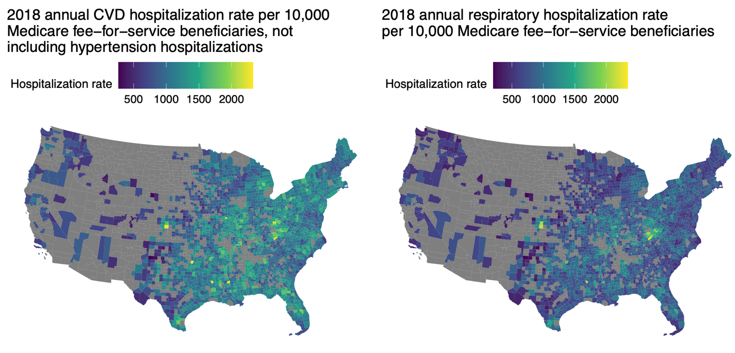**A. B.**

**C.**

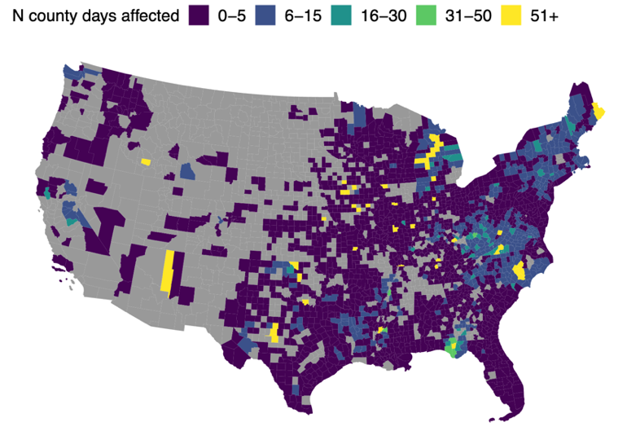

**Figure 1:**

**A**. 2018 Medicare Fee-For-Service county-level cardiovascular hospitalization rate per 100,000 beneficiaries.

**B**. 2018 Medicare Fee-For-Service county-level respiratory hospitalization rate per 100,000 beneficiaries.

**C**. Power outage rate for 2,161 counties included in main analysis of association between 8+ hour power outage exposure and cardiovascular and respiratory hospitalization.

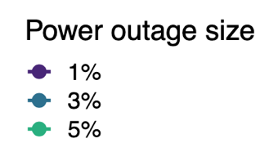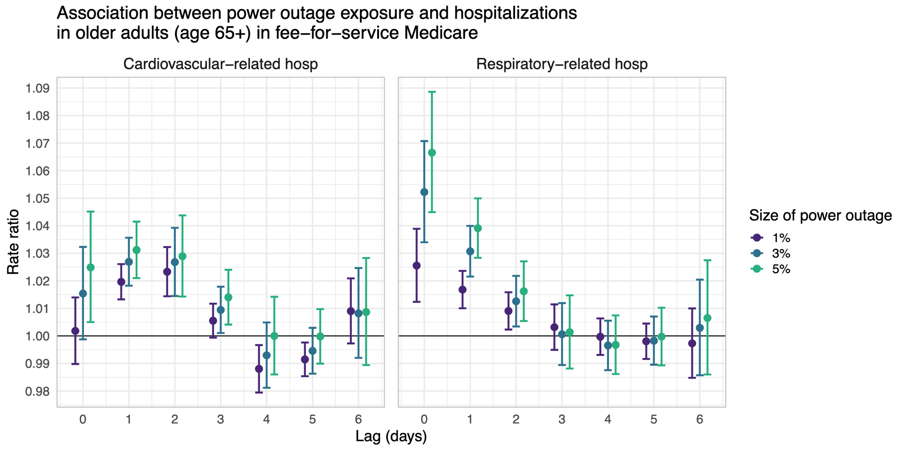

≥ 1%

≥ 3%

≥ 5%

**Figure 2:** Rate ratios and 95% confidence intervals for the association between county-level 8+ hour power outage exposure and CVD and respiratory hospitalizations in US 2018 Medicare Fee-For-Service beneficiaries for outages affecting ≥1%, ≥3%, and ≥5% of county electrical customers. Estimates are from conditional Poisson regression models adjusted for wind speed, temperature, and precipitation.

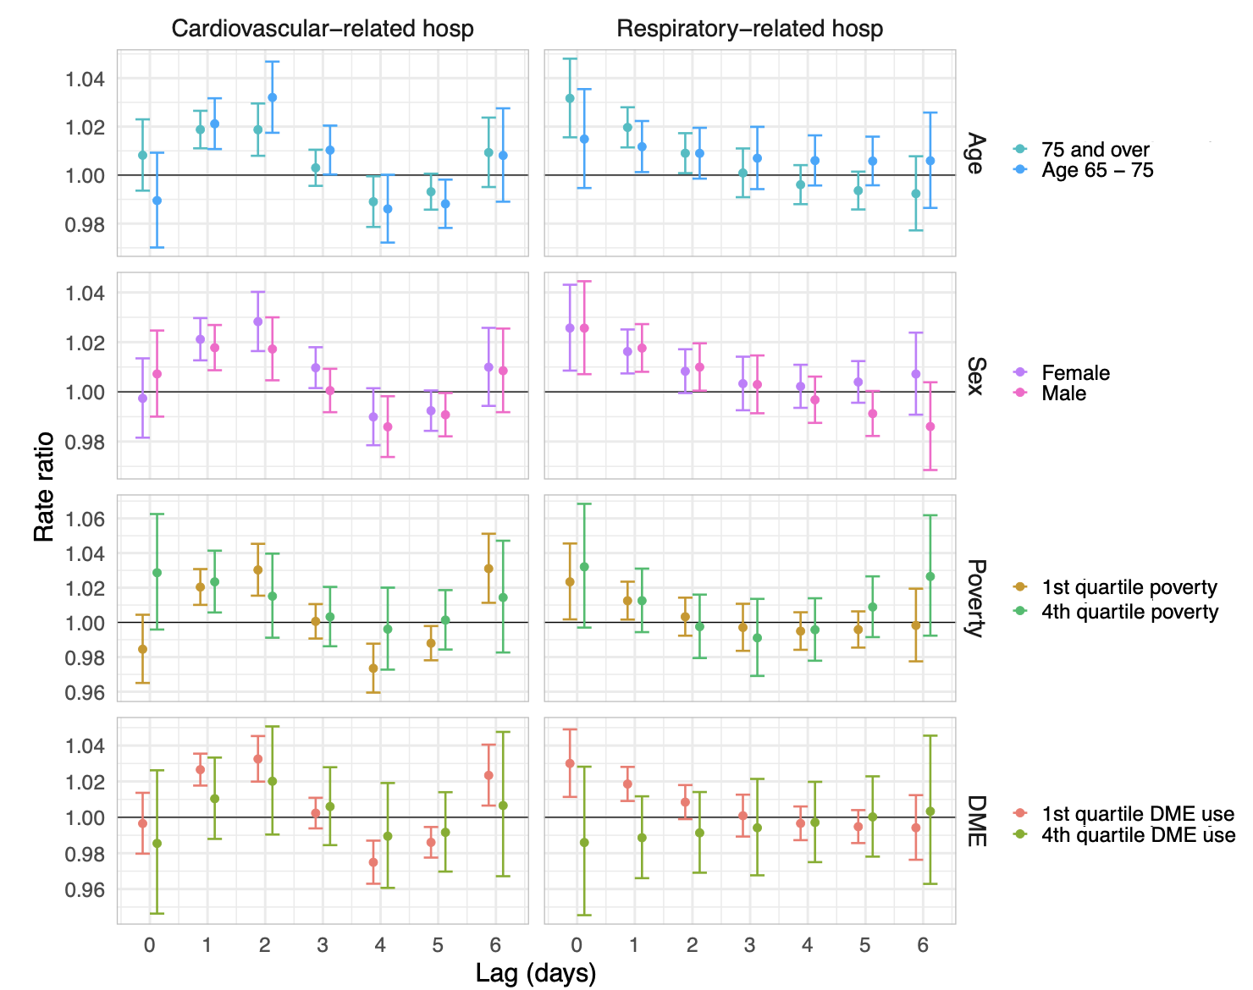

**Figure 3:** Rate ratios and 95% confidence intervals for the association between county-level 8+ hour power outage exposure and CVD and respiratory hospitalizations in US 2018 Medicare Fee-For-Service beneficiaries for outages affecting ≥1% of county electrical customers, stratified by potential effect modifiers: age, sex, county poverty quartile, and county durable medical equipment (DME) use quartile. Estimates are from conditional Poisson regression models adjusted for wind speed, temperature, and precipitation.

**References**

1. Climate Central, Weather-related Power Outages Rising. (2024).

2. U.S. Energy Information Administration, U.S. electricity customers experienced eight hours of power interruptions in 2020. (2021).

3. J. A. Casey, M. Fukurai, D. Hernández, S. Balsari, M. V. Kiang, Power Outages and Community Health: a Narrative Review. *Curr Envir Health Rpt* 7, 371–383 (2020).

4. The US has more power outages than any other developed country. Here’s why. (2020).

5. V. Do, *et al.*, Spatiotemporal distribution of power outages with climate events and social vulnerability in the USA. *Nat Commun* 14, 2470 (2023).

6. United States Environmental Protection Agency, Climate Change Impacts on Energy.

7. Washington Post, Nation at risk of winter blackouts as power grid remains under strain.

8. M. Mango, J. A. Casey, D. Hernández, Resilient Power: A home-based electricity generation and storage solution for the medically vulnerable during climate-induced power outages. *Futures* 128, 102707 (2021).

9. B. Stone, *et al.*, Compound Climate and Infrastructure Events: How Electrical Grid Failure Alters Heat Wave Risk. *Environ. Sci. Technol.* 55, 6957–6964 (2021).

10. A. R. Nunes, General and specified vulnerability to extreme temperatures among older adults. *International Journal of Environmental Health Research* 30, 515–532 (2020).

11. T. Benmarhnia, S. Deguen, J. S. Kaufman, A. Smargiassi, Review Article: Vulnerability to Heat-related Mortality. *Epidemiology* 26, 781–793 (2015).

12. R. D. Meade, *et al.*, Physiological factors characterizing heat-vulnerable older adults: A narrative review. *Environment International* 144, 105909 (2020).

13. N. Veronese, *et al.*, Prevalence of multidimensional frailty and pre-frailty in older people in different settings: A systematic review and meta-analysis. *Ageing Research Reviews* 72, 101498 (2021).

14. C. O. Weiss, C. M. Boyd, Q. Yu, J. L. Wolff, B. Leff, Patterns of Prevalent Major Chronic Disease Among Older Adults in the United States. *JAMA* 298, 1158 (2007).

15. A. Yazdanyar, A. B. Newman, The Burden of Cardiovascular Disease in the Elderly: Morbidity, Mortality, and Costs. *Clinics in Geriatric Medicine* 25, 563–577 (2009).

16. L. Dahlberg, K. J. McKee, A. Frank, M. Naseer, A systematic review of longitudinal risk factors for loneliness in older adults. *Aging & Mental Health* 26, 225–249 (2022).

17. P. Hoang, *et al.*, Interventions Associated With Reduced Loneliness and Social Isolation in Older Adults: A Systematic Review and Meta-analysis. *JAMA Netw Open* 5, e2236676 (2022).

18. N. A. M. Molinari, B. Chen, N. Krishna, T. Morris, Who’s at Risk When the Power Goes Out? The At-home Electricity-Dependent Population in the United States, 2012. *Journal of Public Health Management and Practice* 23, 152–159 (2017).

19. W. Zhang, *et al.*, Power Outage: An Ignored Risk Factor for COPD Exacerbations. *Chest* 158, 2346–2357 (2020).

20. S. Lin, *et al.*, The Joint Effects of Thunderstorms and Power Outages on Respiratory-Related Emergency Visits and Modifying and Mediating Factors of This Relationship. *Environ Health Perspect* 132, 067002 (2024).

21. C. Dominianni, K. Lane, S. Johnson, K. Ito, T. Matte, Health Impacts of Citywide and Localized Power Outages in New York City. *Environ Health Perspect* 126, 067003 (2018).

22. G. B. Anderson, M. L. Bell, Lights Out: Impact of the August 2003 Power Outage on Mortality in New York, NY. *Epidemiology* 23, 189–193 (2012).

23. Oak Ridge National Laboratory, Oak Ridge National Laboratory, EAGLE-I Outage Data 2014-2022. Available at: https://smc-datachallenge.ornl.gov/eagle/ [Accessed 3 January 2025].

24. PowerOutage.us. Available at: https://poweroutage.us/.

25. V. Do, The impact of power outages on cardiovascular hospitalizations among Medicare enrollees in New York State, 2017-2018. *Under review at Epidemiology*.

26. V. Do, *et al.*, Spatiotemporal patterns of power outages co-occurring with individual and multiple severe weather events in the United States, 2018-2020. [Preprint] (2024). Available at: https://www.researchsquare.com/article/rs-4752336/v1 [Accessed 4 January 2025].

27. H. M. Salman, J. Pasupuleti, A. H. Sabry, Review on Causes of Power Outages and Their Occurrence: Mitigation Strategies. *Sustainability* 15, 15001 (2023).

28. X. Deng, *et al.*, The independent and synergistic impacts of power outages and floods on hospital admissions for multiple diseases. *Science of The Total Environment* 828, 154305 (2022).

29. C. Klinger, O. Landeg, V. Murray, Power Outages, Extreme Events and Health: a Systematic Review of the Literature from 2011-2012. *PLOS Currents* (2014).

30. R. J. Carroll, D. Ruppert, L. A. Stefanski, C. M. Crainiceanu, *Measurement Error in Nonlinear Models*.

31. C. Dominianni, *et al.*, Power Outage Preparedness and Concern among Vulnerable New York City Residents. *J Urban Health* 95, 716–726 (2018).

32. T. M. Al-rousan, L. M. Rubenstein, R. B. Wallace, Preparedness for Natural Disasters Among Older US Adults: A Nationwide Survey. *Am J Public Health* 104, 506–511 (2014).

33. J. Xu, Y. Qiang, H. Cai, L. Zou, Power outage and environmental justice in Winter Storm Uri: an analytical workflow based on nighttime light remote sensing. *International Journal of Digital Earth* 16, 2259–2278 (2023).

34. Z. Shah, *et al.*, The electricity scene from above: Exploring power grid inconsistencies using satellite data in Accra, Ghana. *Applied Energy* 319, 119237 (2022).

35. H. McBrien, D. Mork, M.-A. Kioumourtzoglou, J. A. Casey, Assessing potential sources of bias in measuring power outage exposure with simulations. *Under review at Environmental Health*.

36. A. J. Northrop, N. M. Flores, V. Do, P. E. Sheffield, J. A. Casey, Power outages and pediatric unintentional injury hospitalizations in New York State. *Environmental Epidemiology* 8, e287 (2024).

37. U.S. Energy Information Administration Electricity Data. *U.S. Energy Information Administration Electricity Data*. Available at: https://www.eia.gov/electricity/data.php [Accessed 3 January 2024].

38. J. Xiao, *et al.*, Increased risk of multiple pregnancy complications following large-scale power outages during Hurricane Sandy in New York State. *Science of The Total Environment* 770, 145359 (2021).

39. B. G. Armstrong, A. Gasparrini, A. Tobias, Conditional Poisson models: a flexible alternative to conditional logistic case cross-over analysis. *BMC Med Res Methodol* 14, 122 (2014).

40. C. J. Gronlund, K. P. Sullivan, Y. Kefelegn, L. Cameron, M. S. O’Neill, Climate change and temperature extremes: A review of heat- and cold-related morbidity and mortality concerns of municipalities. *Maturitas* 114, 54–59 (2018).

41. C.-M. Tseng, *et al.*, The Effect of Cold Temperature on Increased Exacerbation of Chronic Obstructive Pulmonary Disease: A Nationwide Study. *PLoS ONE* 8, e57066 (2013).

42. B. Alahmad, *et al.*, Associations Between Extreme Temperatures and Cardiovascular Cause-Specific Mortality: Results From 27 Countries. *Circulation* 147, 35–46 (2023).

43. J. T. Abatzoglou, Development of gridded surface meteorological data for ecological applications and modelling. *Intl Journal of Climatology* 33, 121–131 (2013).

44. G. B. Anderson, *et al.*, Heat-related Emergency Hospitalizations for Respiratory Diseases in the Medicare Population. *Am J Respir Crit Care Med* 187, 1098–1103 (2013).

45. A. Gasparrini, B. Armstrong, M. G. Kenward, Distributed lag non‐linear models. *Statistics in Medicine* 29, 2224–2234 (2010).

46. HHS emPOWER program platform. Available at: https://empowerprogram.hhs.gov/ [Accessed 3 January 2024].

47. H. Turner, D. Firth, gnm: Generalized Nonlinear Models. https://doi.org/10.32614/CRAN.package.gnm. Deposited 29 June 2005.

48. W. Wang, J. Yan, Shape-Restricted Regression Splines with R Package splines2. *Journal of Data Science* 498–517 (2021). https://doi.org/10.6339/21-JDS1020.

49. A. Gasparrini, Distributed Lag Linear and Non-Linear Models in *R* : The Package dlnm. *J. Stat. Soft.* 43 (2011).